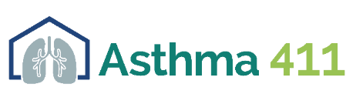
Breathe with Ease Art Contest: Contestant Registration Form
The following questions should be completed by the student. Answers can be handwritten or typed. The form must be submitted electronically with a photo of the artwork and a consent form to asthma411@unthsc.edu by Monday, May 17th, 2021 at 5 PM. Remember to keep your artwork. Winners will be invited to submit their original artwork for display at UNTHSC.

Your Name: Date of Birth:
Mailing Address:
City: ______________________ State: __________________ Zip code: ___________________________
Phone Number: Email:
School Name/Organization: Grade:
City where school is located: _____________________________________________________________
Title of your artwork: ___________________________________________________________________
What media did you use to create the artwork? ______________________________________________
What was your inspiration for creating this piece of art? _______________________________________
_____________________________________________________________________________________
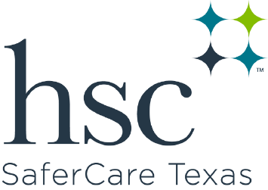
_____________________________________________________________________________________
_____________________________________________________________________________________
How did you hear about the art contest? ___________________________________________________

